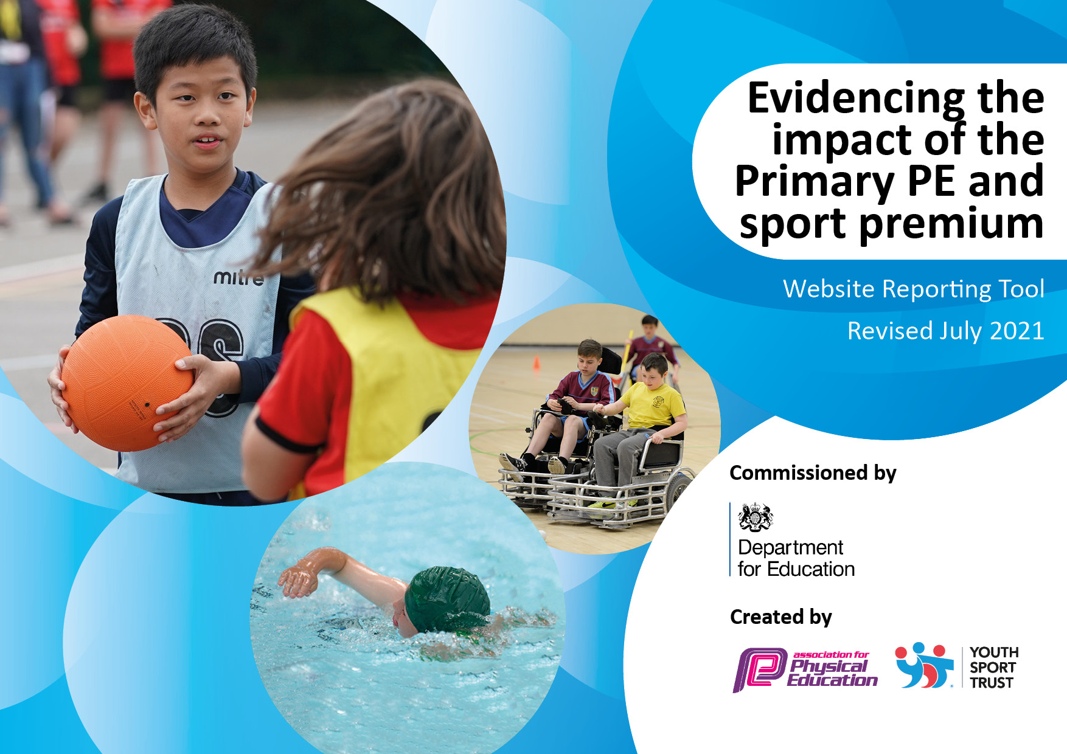
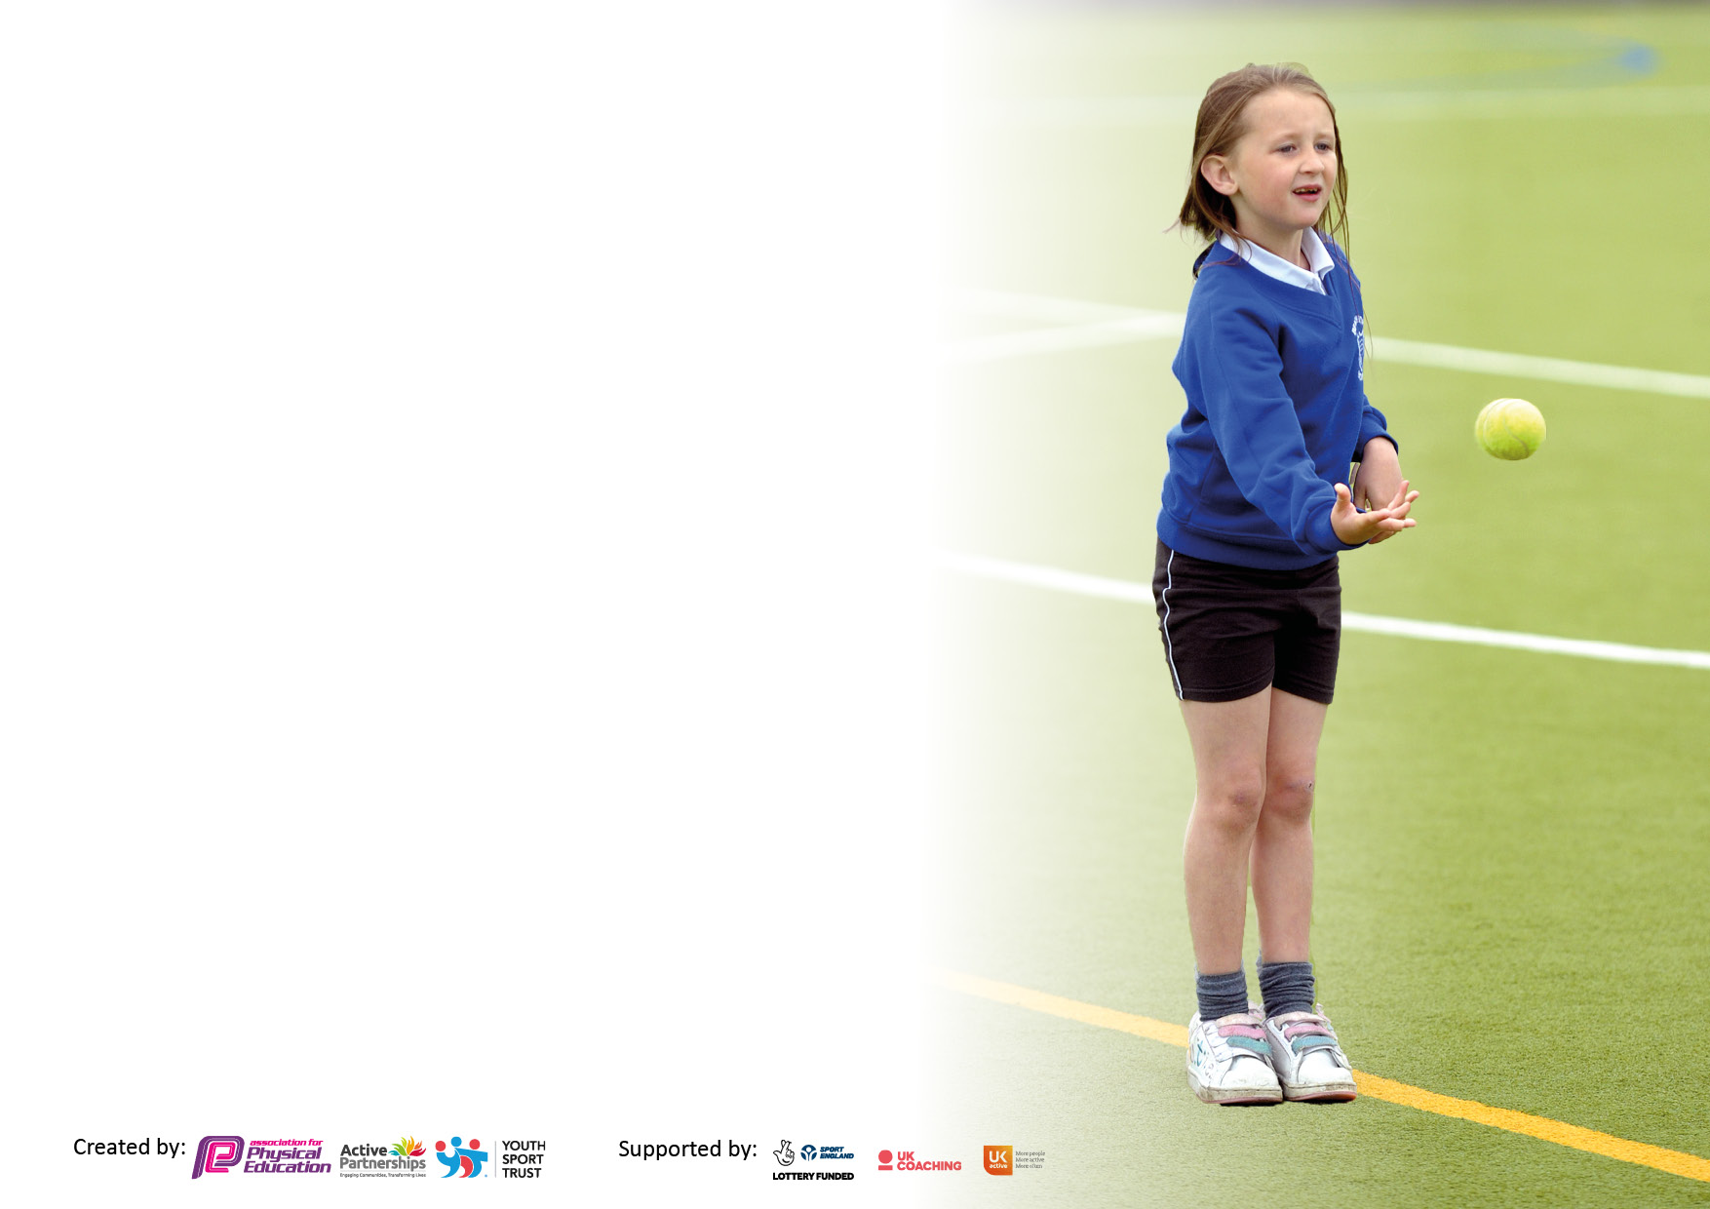

It is important that your grant is used effectively and based on school need. The Education Inspection Framework makes clear there will be a focus on ‘whether leaders and those responsible for governors all understand their respective roles and perform these in a way that enhances the effectiveness of the school’.

Under the Quality of Education Ofsted inspectors consider:
Intent - Curriculum design, coverage and appropriateness
Implementation - Curriculum delivery, Teaching (pedagogy) and Assessment
Impact - Attainment and progress

To assist schools with common transferable language this template has been developed to utilise the same three headings which should make your plans easily transferable between working documents.

Schools must use the funding to make additional and sustainable improvements to the quality of Physical Education, School Sport and Physical Activity (PESSPA) they offer. This means that you should use the Primary PE and sport premium to:

- Develop or add to the PESSPA activities that your school already offer
- Build capacity and capability within the school to ensure that improvements made now will benefit pupils joining the school in future years
- The Primary PE and sport premium should not be used to fund capital spend projects; the school’s budget should fund these.

Pleasevisitgov.ukfortherevisedDfEguidanceincludingthe5keyindicatorsacrosswhichschoolsshoulddemonstrate animprovement.Thisdocumentwillhelpyoutoreviewyourprovisionandtoreportyourspend.DfEencouragesschools to use this template as an effective way of meeting the reporting requirements of the Primary PE and sport premium.

We recommend you start by reflecting on the impact of current provision and reviewing the previous spend.

Schools are required to publish details of how they spend this funding, including any under-spend from 2019/2020, as well as on the impact it has on pupils’ PE and sport participation and attainment. All funding must be spent by 31st July 2022.

We recommend regularly updating the table and publishing it on your website throughout the year. This evidences your ongoing self-evaluation of how you are using the funding to secure maximum, sustainable impact. Final copy must be posted on your website by the end of the academic year and no later than the 31st July 2021. To see an example of how to complete the table please click HERE.
Created by: Supported by:

Details with regard to funding
Please complete the table below.

Total amount allocated for 2021/22 | £16,832.45
How much (if any) do you intend to carry over from this total fund into 2022/23? | £
Total amount allocated for 2022/23 | £17,690
Total amount of funding for 2022/23. To be spent and reported on by 31st July 2023. | £17,690
Swimming Data
Please report on your Swimming Data below.

Meeting national curriculum requirements for swimming and water safety.

N.B. Complete this section to your best ability. For example you might have practised safe self-rescue techniques on dry land which you can then transfer to the pool when school swimming restarts.
Due to exceptional circumstances priority should be given to ensuring that pupils can perform safe self rescue even if they do not fully meet the first two requirements of the NC programme of study
What percentage of your current Year 6 cohort swim competently, confidently and proficiently over a distance of at least 25 metres?  N.B. Even though your pupils may swim in another year please report on their attainment on leaving primary school at the end of the summer term 2021.  Please see note above | 93%
What percentage of your current Year 6 cohort use a range of strokes effectively [for example, front crawl, backstroke and breaststroke]?  Please see note above | 74%
What percentage of your current Year 6 cohort perform safe self-rescue in different water-based situations? | 93%
Schools can choose to use the Primary PE and sport premium to provide additional provision for swimming but this must be for activity over and above the national curriculum requirements. Have you used it in this way? | Yes

Action Plan and Budget Tracking
Capture your intended annual spend against the 5 key indicators. Clarify the success criteria and evidence of impact that you intend to measure to evaluate for pupils today and for the future.

Academic Year: 2022/23 | Total fund allocated: 17,690 | Date Updated:
Key indicator 1: The engagement of all pupils in regular physical activity – Chief Medical Officers guidelines recommend that primary school pupils undertake at least 30 minutes of physical activity a day in school |  |  |  | Percentage of total allocation:
22%
Spent 22%
Intent | Implementation |  | Impact
Your school focus should be clear what you want the pupils to know and be able to do and about  what they need to learn and to  consolidate through practice: | Make sure your actions to achieve are linked to your intentions: | Funding allocated: | Evidence of impact: what do pupils now know and what can they now do? What has changed?: | Sustainability and suggested next steps:
To ensure that all pupils remain active during playtimes.  Ensure extra swimming takes place to ensure all Year 5 and Year 6 pupils reach ARE.  Golden Mile  Purchase additional Gazebo’s for supporting PE/Sports during summer months | - Alternative play/sports equipment purchased to ensure engagement for lunch club.  - Age appropriate equipment for year groups in the playground.  - Extra swimming sessions to be provided for those Year 6 pupils identified as not at ARE.  - To allow children to start their day in an active way – walk, jog or run for 10mins on designated route.  - Introduce class trophy and Golden Mile Superstar Medals.  - Allow children to have some sub protection during sports events, PE and lunch times | £1956.90  £650  £630  £660  Total - £3896.90  Spent - £3896.90 | Pupils will have new opportunities to remain active with new games and equipment.  EYFS and Year 1 children develop balance, agility, strength and flexibility skills when using new equipment during free play.  Most Year 6 pupils will meet the expected swimming standard.  Children are running more laps than the previous year at this stage.  Children have access to sports and physical activity all year round with appropriate protection from the weather | Play ground game markings to be installed to further encourage physical participation.  Challenges against other schools.
Key indicator 2: The profile of PESSPA being raised across the school as a tool for whole school improvement |  |  |  | Percentage of total allocation:
 |  |  |  | 1%
Intent | Implementation |  | Impact
Your school focus should be clear what you want the pupils to know and be able to do and about  what they need to learn and to  consolidate through practice: | Make sure your actions to achieve are linked to your intentions: | Funding allocated: | Evidence of impact: what do pupils now know and what can they now do? What has changed?: | Sustainability and suggested next steps:
All staff to continue to emphasise the need to stay active to all pupils.  Decorating PE hall to make it feel like a sporting venue. | - Teachers model the importance of staying active by participating in PE sessions with their class.  - Purchase wall transfers of different sports. | £  £161.40  Total - £161.40  Spent – £161.40 | Pupils have been provided with effective modelling of new skills and as a result have mastered these with confidence.  Children are excited to see the decorations and talk about the physical activity shown. | Provide opportunities for parents to participate in a PE workshop with their child.  Provide more EYFS specific opportunities.  Provide opportunities for all pupils to take part in a healthy and active life day

Key indicator 3: Increased confidence, knowledge and skills of all staff in teaching PE and sport |  |  |  | Percentage of total allocation:
 |  |  |  | 16%
Intent | Implementation |  | Impact
Your school focus should be clear | Make sure your actions to | Funding | Evidence of impact: what do | Sustainability and suggested
what you want the pupils to know | achieve are linked to your | allocated: | pupils now know and what | next steps:
and be able to do and about | intentions: |  | can they now do? What has
what they need to learn and to |  |  | changed?:
consolidate through practice:
Cluster PE Lead (PS) to support teachers who may require further CPD.  Teachers and TA’S are supported in developing new and different practices so that pupils are supported and challenged in line with their age and stage.  Purchase new scheme of work | - Cluster PE Lead (PS) to plan and team teach with staff members identified from audit.  - PE Leader observes, to ensure PE lessons are delivered to a high quality using the agreed scheme. 5 days release | £  £1250  £1650  Total - £2900  Spent £2900 | Teachers will feel more confident to deliver new and different physical games/activities.  Staff are delivering quality lessons  Planning now shows progression and emcompasses YR-Y6 | Purchase new PE scheme that encompasses EYFS and has assessment tracking - COMPLETED
Key indicator 4: Broader experience of a range of sports and activities offered to all pupils |  |  |  | Percentage of total allocation:
 |  |  |  | 46%
Intent | Implementation |  | Impact
Your school focus should be clear | Make sure your actions to | Funding | Evidence of impact: what do | Sustainability and suggested
what you want the pupils to know | achieve are linked to your | allocated: | pupils now know and what | next steps:
and be able to do and about | intentions: |  | can they now do? What has
what they need to learn and to |  |  | changed?:
consolidate through practice:
Additional achievements:  Balanceability bikes for EYFS and KS1. To ensure that all children can experience, practise and enjoy riding a bike. This will begin to ensure that those children have a love of exercise through biking.  Bike ability for Year 6 cycling proficiency participation promoting road safety and developing bike handling skills.  Provide cluster opportunities where pupils can participate in competitive and non-competitive sports and activities  Provide a range of sporting opportunities for the children through a sports week.  Updating EYFS provision to enhance physical activity | - Balance and pedal bikes, balance bike training, helmets and balance training materials.  - Children to take part in a week long course with training members.  - Pupils will all have opportunities to try a new sport/activity in a competitive or non-competitive event.  - Hire equipment and coaches for alternative sports not provided by the school. | £610  £1.50 ( per child)  £37.50 (25 chn)  £2000  £5500  Total – £8147.50  Spent - £8927.50 | All EYFS and KS1 children to become confident and able to ride a bike, including stopping, turning and adjusting their balance over tricky terrain.  Year 6 children will be safer cycling outside of school and know how to cycle on the road.  Some pupils will have continued new sport beyond the school e.g. joined a specific sports club… | New resources and further training will be required yearly as staff move around the school. Maintenance of the bikes will have to be budgeted for in the future.  Road/track markings to be painted onto the playground to teach road/path etiquette.  Climbing wall was an addition to this and a huge success. Rebook every year going forward.

Key indicator 5: Increased participation in competitive sport |  |  |  | Percentage of total allocation:
 |  |  |  | 4%
Intent | Implementation |  | Impact
Your school focus should be clear | Make sure your actions to | Funding | Evidence of impact: what do | Sustainability and suggested
what you want the pupils to know | achieve are linked to your | allocated: | pupils now know and what | next steps:
and be able to do and about | intentions: |  | can they now do? What has
what they need to learn and to |  |  | changed?:
consolidate through practice:
Provide all pupils with competitive sporting opportunities, whether within school or the local cluster | - North Wiltshire Cluster contribution to ensure entry to all events.  - Transport and staff release | £200  £500  Total - £700  Spent - £700 | Increased participation of the number of children taking part in sport since COVID-19. Events achieved success in include Netball, cross country and girls football. | Continued release time for staff to ensure that all children experience the thrill of competition in a variety of events.

Signed off by
Head Teacher: | Andrew Farmer
Date: | 25/7/23
Subject Leader: | Andrew Large
Date: | 25/7/23
Governor: | Stuart James
Date: | 25/7/23

