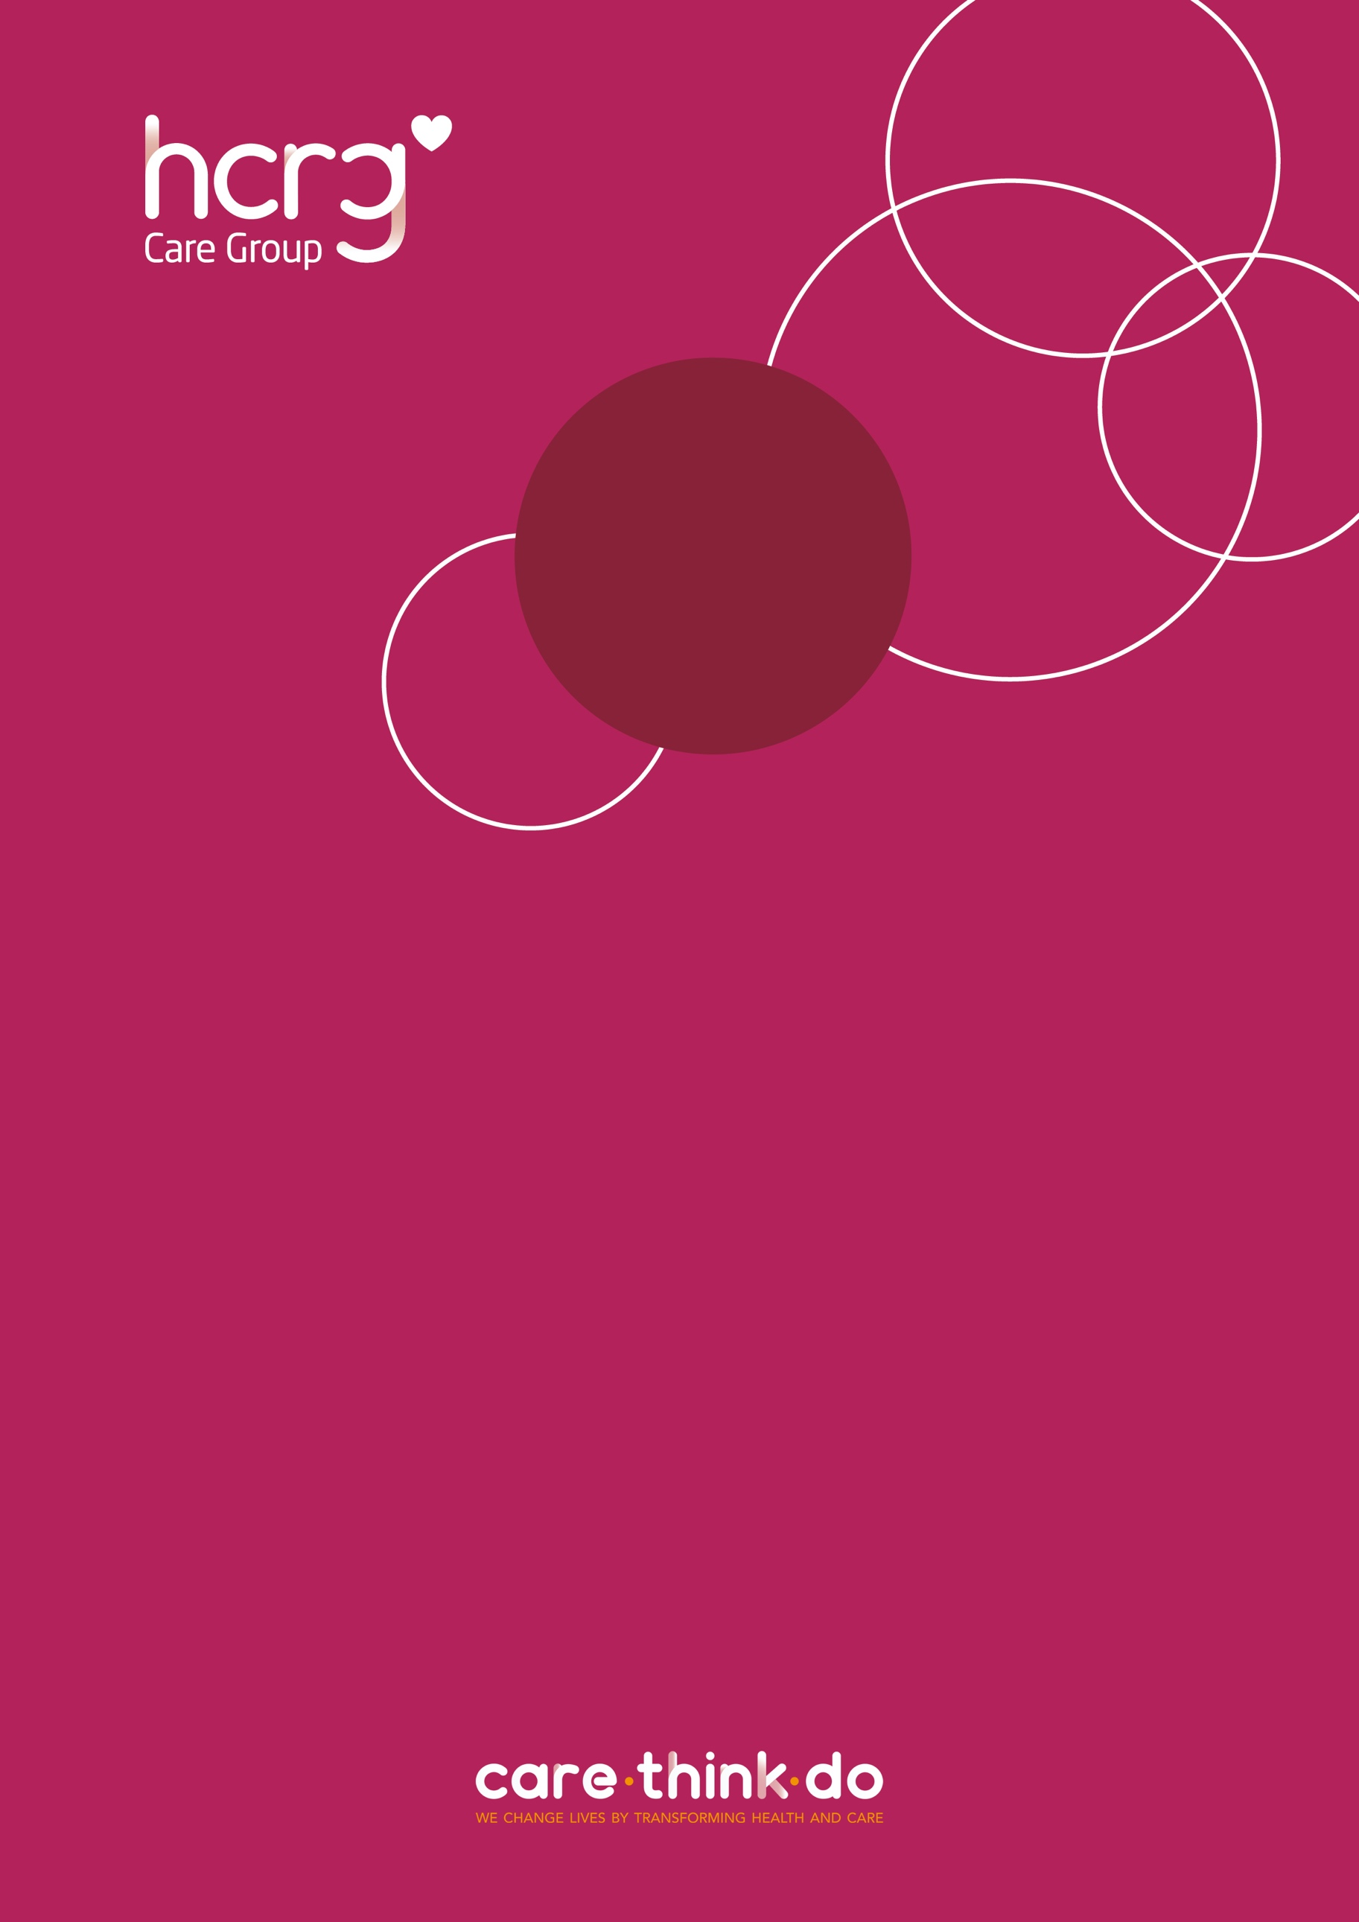

**School Nursing Service**

**The School Nursing Service provides health-related, confidential support and advice to children and young people, their parents and carers, professionals, and community settings across Wiltshire.**

* **Mental and emotional health**
* **Physical health**
* **Healthy Lifestyles**
* **Sex & Relationships**
* **Drugs & Alcohol**
* **And much more…**

**You can find more information about the School Nursing Service at**

**wiltshirechildrensservices.co.uk/our-services/school-nursing/**

**How can I refer to the service?**

**Self-referrals can be made by young people (secondary school-aged) through attending School Nursing Service drop-ins or via Single Point of Access (details provided below).**

**Referrals can be made by parents/carers, as well as other agencies such as – education staff, GPs and social care (with parental/carer consent), by contacting Single Point of Access (SPA) –**

**0300 247 0090 (Monday – Friday 09:00 - 17:00)**

**vcl.wiltshirespa@nhs.net (email)**

**A ‘Request for support’ form can be accessed at**

**wiltshirechildrensservices.co.uk/our-services/spa/**